

CIPS Message Definition Report
Part 1: Clearing and Settlement—Central Counterparty Funds Settlement

V1.0.0
October 2019

Important Note: This document is to collate the previous version of the standard in a normalized way, and will not affect the current standard and the operation of the system; if you have any questions, please contact Standardization Department of CIPS at bzb@cips.com.cn.

Revision Record
Version Number | Date | Revision Note | Scope
V1.0.0 | 26-10-2019 | [C]  CIPS Message Definition Report — Part 1: Central Counterparty Funds Settlement | All
Note: Change statuses are C — created, A — added, M — modified, and D — deleted.
Table of Contents

1 Introduction 1
1.1 Terms and Definitions 1
1.2 Abbreviations and Acronyms 2
1.3 Document Scope and Objectives 2
1.4 References 2
2 Scope and Functionality 2
2.1 Background 2
2.2 Scope 2
2.3 Groups of MessageDefinitions and Functionality 3
3 BusinessRoles and Participants 3
3.1 Central Counterparty Funds Settlement Business 3
4 BusinessProcess Description 4
4.1 BusinessProcess Diagram 4
5 Description of BusinessActivities 4
5.1 RequestForCCPSettlement/CCPSettlementNotice (cips.132) 5
6 BusinessProcesses 6
6.1 CCP Settlement 6
6.1.1 Normal Process of CCP Settlement 7
6.1.2 Special Process of CCP Settlement 8
7 Example 9
7.1 RequestforCCPSettlement <cips.131.001.01> 9

- Introduction
  - Terms and Definitions
The terms involved in this document are defined as follows:
Term | Definition
BusinessRole | A BusinessRole represents an entity (or a class of entities) of an actual business.
Participant | A functional role played by a BusinessRole in a particular BusinessProcess or BusinessTransaction.
BusinessProcess | Business activities undefined but undertaken within a BusinessArea whereby each BusinessProcess fulfills one type of business activities and whereby a BusinessProcess may include and extend other BusinessProcesses.
BusinessTransaction | A particular solution that meets the communication requirements and the interaction requirements of a particular BusinessProcess and BusinessArea.
MessageDefinition | Formal description of the structure of a message instance.

The CIPS terms involved in this document are defined as follows:
Term | Description
Cross-border Interbank Payment System (CIPS) | CIPS provides fund clearing and settlement service for its Participants’ cross-border RMB payment transactions, financial market transactions, etc.
CIPS Direct Participant | CIPS Direct Participant refers to a domestic or an overseas institution that has a CIPS code and handles cross-border RMB payment and settlement businesses directly through CIPS. The operating agency of CIPS will open a CIPS account for each Direct Participant bank, and will also open a CIPS account for each Direct Participant FMI as required by prudent management.
CIPS Indirect Participant | CIPS Indirect Participant refers to a domestic or an overseas institution that has not opened a CIPS account but has a CIPS’ bank code and entrusts an appropriate CIPS Direct Participant to handle cross-border RMB payment and settlement businesses through CIPS.
Initiator | Initiator refers to an individual or institution that initially creates a request for payment or information.
Receiver | Receiver refers to an individual or institution that ultimately receives a request for payment or information.
Central Counterparty Funds Settlement (Central Counter Party Business) | Central Counter Party Business refers to the business in which Central Counterparty becomes the buyer of the seller and the seller of the buyer after inheriting the rights and obligations of both parties in concluding a contract, makes payments to the creditor after deducting the payments from the debtor’s account, and delivers the bond at the same time.
Custodian Bank | Custodian Bank refers to a domestic direct participant bank that meets the requirements and has signed a fund custody agreement with a direct participant having no HVPS clearing account to provide related services such as initial prefunding (reserved prefunding) and fund increase (frozen fund increase).
Entrusted bank | Entrusted bank refers to an overseas CIPS direct participant that has entered into a payment settlement service agreement with a Custodian Bank.

  - Abbreviations and Acronyms
Abbreviation/Acronyms | Definition
CIPS | Cross-border Interbank Payment System
CCP | Central Counter Party Business
  - Document Scope and Objectives
This document is the first part of the Remittance Message Definition Report (MDR) and describes the BusinessTransactions and underlying message set. For the sake of completeness, the document may also describe the BusinessActivities that are not in the scope of the BusinessProcesses covered in this document.
This document describes the following:
- the BusinessProcesses scope
- the BusinessRoles involved in these BusinessProcesses
The main objectives of this document are as follows:
- to explain the BusinessProcesses and BusinessActivities these messages have addressed
- to explain the BusinessProcesses and BusinessActivities these messages have addressed
- to give a high-level description of the BusinessProcesses and associated BusinessRoles
- to explain the BusinessProcesses and related Participants
- to present a list of MessageDefinitions
  - References
Document | Version | Date | Author
Message Exchange Standard for CNAPS2 | V1.4.7 | 05-2017 | China National Clearing Center, the People’s Bank of China
CIPS (Phase II) Requirements Specification | V1.0.0 | 05-2017 | China National Clearing Center, the People’s Bank of China
CIPS Message Exchange Standard V2.1.0 | V2.1.0 | 11-01-2019 | Payment System Development Center, China National Clearing Center, the People’s Bank of China
Requirements Specification for Multi-debit/credit Transfer by Clearing Institution | V0.5.0 | 01-2019 | China National Clearing Center, the People’s Bank of China
- Scope and Functionality
  - Background
This Message Definition Report covers a set of 4 messages developed by CIPS for central counterparty funds settlement.
  - Scope
This message set covers the BusinessProcesses of central counterparty funds settlement. The following 4 messages are used to describe the BusinessProcesses:
- RequestforCCPSettlement (cips.131.001.01): After a deal is made between both parties of a financial market transaction, Central Counterparty sends a RequestforCCPSettlement (cips.131) message to CIPS. Upon receiving the message, CIPS carries out settlement and sends a CCPSettlementNotice (cips.132) message to Central Counterparty and related Direct Participants.
- CCPSettlementNotice (cips.132.001.01): CIPS accepts a RequestforCCPSettlement (cips.131) message and replies to Central Counterparty with a CCPSettlementNotice (cips.132) message after CIPS completes fund settlement.
- CCPSettlementNotice (cips.622.001.01): CIPS accepts a RequestforCCPSettlement (cips.131) message and replies to Central Counterparty with a CCPSettlementNotice (cips.132) message after CIPS completes fund settlement. CIPS returns the settlement information and detailed information to Direct Participants through a CCPSettlementNotice (cips.622) message.
- MessageAbandonNotice (cips.912.001.01): CIPS sends a cips.912 to abandon received message if CIPS can neither carry out any business processing nor reply with a business-level CommonConfirmation message.
  - Groups of MessageDefinitions and Functionality
MessageDefinition | ISO 20022 Identifier | CIPS Identifier
RequestForCCPSettlement | pacs.009.001.06 | cips.131.001.01
CCPSettlementNotice | / | cips.132.001.01
CCPSettlementNotice | camt.054.001.06 | cips.622.001.01
MessageAbandonNotice | / | cips.912.001.01
- BusinessRoles and Participants
A BusinessRole represents an entity (or a class of entities) of the real world, physical or legal, including a person or corporation. Examples of BusinessRoles: “Financial Institution”, and so on.
A Participant is a functional role played by a BusinessRole in a particular BusinessProcess or BusinessTransaction. Examples of Participants: the “user” of a system, “debtor”, “investor”, and so on.
The relationship between BusinessRoles and Participants is many-to-many. A BusinessRole can act as different Participants at different moments or at the same time. For example, a BusinessRole can be involved as the “user” of a system, a “debtor” and an “investor” at the same time. In addition, different BusinessRoles can be involved as the same Participant.
  - Central Counterparty Funds Settlement Business
The BusinessRoles and Participants in central counterparty funds settlement business are described below.
Participant and BusinessRole Definitions
Participant | Definition
CIPS | Cross-border Interbank Payment System
Direct Participant | A domestic/overseas banking or other financial institution that directly accepts the fund settlement services provided by CIPS and directly participates in CCP settlement.
CCP | Central Counterparty is referred to as CCP. In the financial market, CCP intervenes between the contractual counterparties to become the “buyer’s seller” and the “seller’s buyer”, and becomes the only settlement opponent of all settlement participants.
BusinessRole | Definition
CIPS Participant | A participant that directly interacts with CIPS
Clearing System | Cross-border Interbank Payment System

Participant and BusinessRole Matrix
BusinessRole  Participant | CIPS Participant | Clearing System
CIPS |  | √
Direct Participant | √
CCP | √

- BusinessProcess Description
This section describes the BusinessProcesses. Description of the BusinessProcesses and the information in the BusinessProcesses can help to identify relationships between the BusinessRoles.

  - BusinessProcess Diagram
The following figure shows the BusinessProcesses of central counterparty funds settlement.
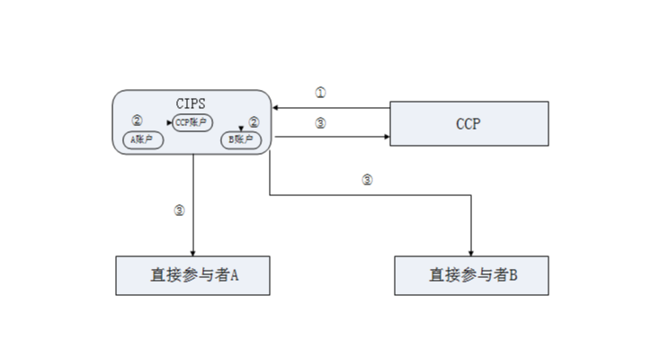
Account A
Account B
CCP Account
Direct Participant A
Direct Participant B

The BusinessProcesses are as follows:
① Central Counterparty sends a Packet message to CIPS, and this packet may contain one or more CCP receivable(s) and/or CCP payable(s); CIPS carries out accounting treatment one by one, without requirement for batch operation of direct participants’ accounts involved in this packet.
② Upon receiving the Packet message, CIPS verifies digital signatures and performs business checks; after the message passes the checks, CIPS starts to process this packet.
CIPS records the total amount of payables in this packet and sets it as a parameter. Only when the balance (excluding SSS’ temporary deposit) in CCP account is greater than or equal to this parameter can all the payables in this packet begin to be settled. This part of balance is not allowed to be used by any other business of an institution until all the payables in this packet are successfully settled. This parameter can be set to invalid after each packet has been processed. If the current packet has not been processed, CIPS directly rejects any packet request received later.
③ CIPS notifies Central Counterparty and Direct Participants of the processing results.
Upon receiving a CCP packet, CIPS first performs business checks; after it passes the checks, CIPS starts to process the transactions; when CCP receivables are in the ACSC or PDNG status and CCP payables are in the ACSC status, it is considered that the CCP packet has been resolved. If the CCP packet only contains receivables or only contains payables, the judgment method is consistent; when CCP receivables are in the ACSC or PDNG status or CCP payables are in the ACSC status, it is considered that the CCP packet has been processed. CIPS does not process CSD payment business until CCP settlement has been processed.
When CIPS receives a CCP packet and starts to process this packet, CCP may not cancel this packet. The priority of CCP receivables should be placed after DNS business of commercial banks. At the end of session or at the end of day, CIPS will return CCP receivables that have not yet been settled.
- Description of BusinessActivities
This section presents the different BusinessActivities within each BusinessProcess. The BusinessActivities of a process are described with an activity diagram. The following is an introduction to the activity diagram.
describes the general lifecycle of a business process;
Start Point  shows where the lifecycle of the business process commences, and End Point  shows where the lifecycle of the business process may end;
Lozenge (or Diamond) indicates that a choice between several actions can be made;

There are activity streamlines between Participants;
Information in the BusinessActivities is transmitted from a Participant to another.
  - RequestForCCPSettlement/CCPSettlementNotice (cips.132)
Central Counterparty sends a RequestForCCPSettlement message to CIPS; upon receiving the message, CIPS performs message format check and double accounting check. If the message fails to pass message format check and double accounting check, CIPS will reject to process the message, abandon the message, and send a “MessageAbandonNotice” message to Central Counterparty, prompting that the message cannot be identified; after the message passes message format check and double accounting check, CIPS will perform business legality check and digital signature validity check. If the message fails to pass business legality check and digital signature validity check, CIPS will reject the message, and send an “CCPSettlementNotice（cips.132）” message to inform Central Counterparty of the error causes; after the message passes the checks, CIPS will look over the pending flag and judge whether it is pending for settlement. If the flag is Pended, CIPS will execute fund settlement; if the flag is Pending, CIPS will not execute fund settlement until the pending ends; if the business has not yet been settled at day end, CIPS will execute end-of-day return. After fund settlement, during pending for settlement or in case of end-of-day return, CIPS will send a CCPSettlementNotice（cips.622） message to Central Counterparty in real time, and return the business processing results to the Direct Participants through a CCPSettlementNotice（cips.132） message.

Send a RequestForCCPSettlement message to CIPS
Cental Counterparty
Yes
No
Receive the MessageAbandonNotice message
Receive the CommonConfirmation message
Receive the RequestForCCPSettlement message
Message review
Send a MessageAbandonNotice message to Cental Counterparty
No
Yes
Yes
Yes
No
Pass message format check and double accounting check or not
Pass business legality check and digital signature validity check or not
Send a CommonConfirmation message to Cental Counterparty
Pending for settlement
Check whether there is a pending flag
Settlement succeeds at day end or not
End-of-day returned
Settled
No
Receive the CCPSettlementNotice (cips.132) message
Send a CCPSettlementNotice (cips.132) message to Cental Counterparty
Send a CCPSettlementNotice (cips.622) message to Direct Participants
Receive the CCPSettlementNotice (cips.622) message
Direct Participants
- BusinessProcesses
This section describes the message flows based on the following activity diagrams to show the specific communication processes in the BusinessProcesses or BusinessTransactions.
  - CCP Settlement
CIPS accepts a RequestforCCPSettlement message from a Participant; after fund settlement, CIPS replies to Central Counterparty with an CCPSettlementNotice (cips.132) message, and return the business processing results to the Initiating Participant through a CCPSettlementNotice (cips.622) message.
    - Normal Process of CCP Settlement
The business initiated by a Participant is settled smoothly.
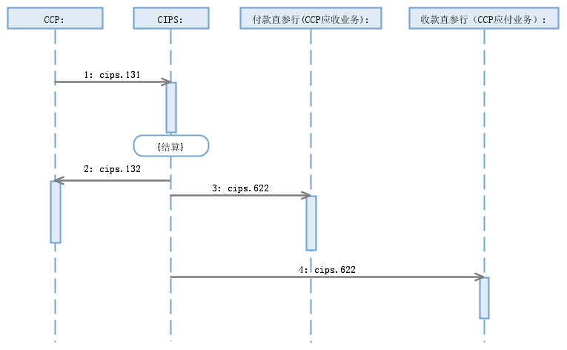
Debtor Direct Participant Bank
(CCP receivabels)
{Settled}
Creditor Direct Participant BankCreditor Direct Participant Bank (CCP payables)

In case of pending for settlement, CIPS will reply to CCP with an CCPSettlementNotice（cips.132） message indicating that the payment status is ACSC or PDNG, and send a CCPSettlementNotice (cips.622) message indicating that the payment status is PDNG to Debtor Direct Participant Bank (CCP receivables); after settlement, CIPS will continue to reply to CCP with a whole-volume CCPSettlementNotice (cips.132) message, and send a CCPSettlementNotice (cips.622) message to Debtor Direct Participant Bank that need to complete settlement subsequently.
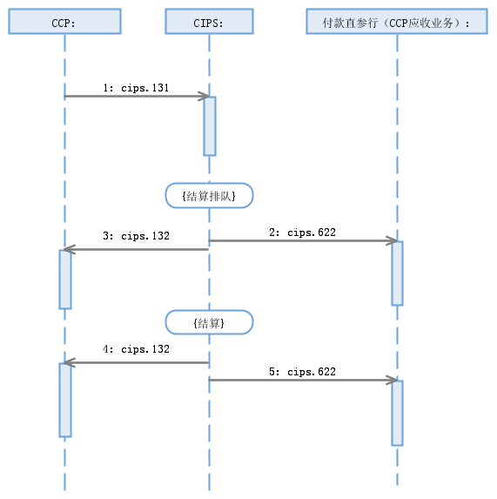
Debtor Direct Participant Bank (CCP receivabels)
{Pending for settlement}
{Settled}
    - Special Process of CCP Settlement
If the business initiated by a Participant has not yet been settled at day end after pending for settlement, CIPS will return the business.
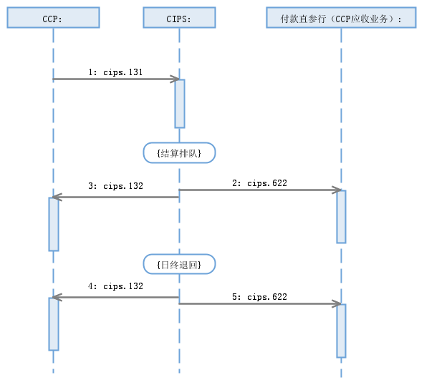
Debtor Direct Participant Bank
(CCP receivabels)
{Pending for settlement}
{End-of-day returned}
The business initiated by a Participant is rejected by CIPS as a whole packet due to the error(s) found in business checks.
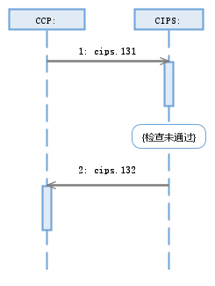
Debtor Direct Participant Bank (CCP receivabels)
{Pending for settlement}
{Settled}
{Failure to pass the checks}
CIPS abandons a RequestForCCPSettlement message sent by a Participant due to existence of CCP settlement being processed, nonexistence of DirectParticipantIdentification, invalid DirectParticipantIdentification, wrong message format or double accounting.
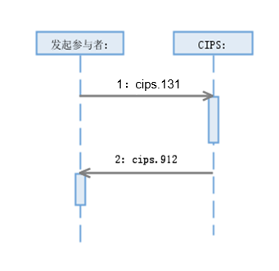
Initiating Participant:

- Example
  - RequestforCCPSettlement <cips.131.001.01>
Message Instance:
<PrtryMsg>
<MsgId>
<Ref>2017121100000814</Ref>
</MsgId>
<PrtryData>
<Tp>cips.131.001.01</Tp>
<Data>
<InstgPty>ICBKCNBJXXX</InstgPty>
<CdtDbtInf>
<Id>BKCHCNBJXXX</Id>
<CdtDbtInd>DBIT</CdtDbtInd>
<IntrBkSttlmAmt Ccy="CNY">2184.79</IntrBkSttlmAmt>
</CdtDbtInf>
<CdtDbtInf>
<Id>ABOCCNBJXXX</Id>
<CdtDbtInd>CRDT</CdtDbtInd>
<IntrBkSttlmAmt Ccy="CNY">2184.79</IntrBkSttlmAmt>
</CdtDbtInf>
<RmtInstr>
<InstrId>2017121100000089</InstrId>
<TxId>2017121100000089</TxId>
<CdtDbtInd>DBIT</CdtDbtInd>
<IntrBkSttlmAmt Ccy="CNY">3184.44</IntrBkSttlmAmt>
<Prtry>SBTB</Prtry>
<Id>BKCHCNBJXXX</Id>
<BrnchId>BKCHAEADXXX</BrnchId>
<IntrmyAgt>
<Id>BKCHFRPPXXX</Id>
<Nm>Name of Intermediary Agent</Nm>
</IntrmyAgt>
<AgtId>BKCHFRPPXXX</AgtId>
<Acct>
<Id>1234567890</Id>
<Nm>Name of Debtor</Nm>
</Acct>
<PstlAdr>
<AdrLine>Address 1 of Debtor</AdrLine>
<AdrLine>Address 2 of Debtor</AdrLine>
<AdrLine>Address 3 of Debtor</AdrLine>
<CtryOfRes>CN</CtryOfRes>
</PstlAdr>
<RmtInf>RequestforCCPSettlement</RmtInf>
</RmtInstr>
<RmtInstr>
<InstrId>2017121100000189</InstrId>
<TxId>2017121100000189</TxId>
<CdtDbtInd>CRDT</CdtDbtInd>
<IntrBkSttlmAmt Ccy="CNY">999.65</IntrBkSttlmAmt>
<Prtry>SBTB</Prtry>
<Id>BKCHCNBJXXX</Id>
<BrnchId>BKCHJPJTXXX</BrnchId>
<IntrmyAgt>
<Id>BKCHRUMMXXX</Id>
<Nm>Name of Intermediary Agent</Nm>
</IntrmyAgt>
<AgtId>BKCHRUMMXXX</AgtId>
<Acct>
<Id>1234567890</Id>
<Nm>Name of Creditor</Nm>
</Acct>
<RmtInf>RequestforCCPSettlement</RmtInf>
</RmtInstr>
<RmtInstr>
<InstrId>201712110000289</InstrId>
<TxId>2017121100000289</TxId>
<CdtDbtInd>DBIT</CdtDbtInd>
<IntrBkSttlmAmt Ccy="CNY">1184.29</IntrBkSttlmAmt>
<Prtry>SBTB</Prtry>
<Id>ABOCCNBJXXX</Id>
<BrnchId>ABOCSGSGXXX</BrnchId>
<IntrmyAgt>
<Id>ABOCHKHHXXX</Id>
<Nm>Name of Intermediary Agent</Nm>
</IntrmyAgt>
<AgtId>ABOCHKHHXXX</AgtId>
<Acct>
<Id>1234567890</Id>
<Nm>Name of Debtor</Nm>
</Acct>
<RmtInf>RequestforCCPSettlement</RmtInf>
</RmtInstr>
<RmtInstr>
<InstrId>201712110000389</InstrId>
<TxId>2017121100000389</TxId>
<CdtDbtInd>CRDT</CdtDbtInd>
<IntrBkSttlmAmt Ccy="CNY">3369.08</IntrBkSttlmAmt>
<Prtry>SBTB</Prtry>
<Id>ABOCCNBJXXX</Id>
<BrnchId>ABOCDEFFXXX</BrnchId>
<IntrmyAgt>
<Id>ABOCUS33XXX</Id>
<Nm>Name of Intermediary Agent</Nm>
</IntrmyAgt>
<AgtId>ABOCUS33XXX</AgtId>
<Acct>
<Id>1234567890</Id>
<Nm>Name of Creditor</Nm>
</Acct>
<PstlAdr>
<AdrLine>Creditor Address 1</AdrLine>
<CtryOfRes>CN</CtryOfRes>
</PstlAdr>
<RmtInf>RequestforCCPSettlement</RmtInf>
</RmtInstr>
</Data>
</PrtryData>
</PrtryMsg>
</Document>

